# Fleshing Out Curse of Strahd: Yester Hill I - The Great Battle

Hello everyone! I hope you all had wonderful holidays this winter. On the brink of the New Year, I've got a new chapter for you guys. :)

Yester Hill is yet another famously difficult area in CoS, known for TPKs all around. I also don't know why, but I've been avoiding my write-up on this location for ages. I'm not really sure what happened, but I procrastinated the hell out of this guide. It's here now though, so let's get this party started!

## The Background of Yester Hill

### Connection to the Fanes

* ***Yester Hill is, first and foremost, a graveyard***. It's a giant hill surrounded by ancient graves after all. Secondly, Yester Hill is a shrine to the Mountain Fane, the Huntress of the Ladies Three.
  + The Ladies Three were a trio of ancient archfey goddesses that ruled the valley long before Strahd's arrival. However, Strahd desecrated their shrines and stole their power for himself, making himself "the Land." So long as Strahd has the power of the Fanes, he's almost unbeatable in combat. Players will have to reconsecrate the Fanes to weaken Strahd enough to face him.
  + For more information on the Fanes, take a look at [my posts here](https://www.reddit.com/r/CurseofStrahd/comments/9l5zfh/fleshing_out_curse_of_strahd_the_fanes_and_the/).
* ***Reskinning the Gulthias Tree***
  + To that effect, I've reworked the Gulthias Tree to be a link to the Huntress. As I detailed in those Fanes posts, the Huntress is a nature-based death goddess. While drab (as most things associated with death are) she is far from evil. And neither is the tree.
  + The Gulthias Tree is a grotesque tree of death, but isn't actually evil. Its branches are black. When cut, it literally bleeds. And beneath its roots is a gateway to the land of the dead. But it is still *not* evil.
  + The Gulthias Tree is one of the oldest living things in the valley, far outdating everything but perhaps the mountains themselves. The forest folk built the shrine on top Yester Hill because it was close to the tree.
  + I've placed an additional dungeon under the Gulthias Tree for reconsecrating the Mountain Fane, but it is only accessible to those who are actually looking for it. That means that players won't find this dungeon on their first visit to Yester Hill and it is reserved for late game completion (after the Amber Temple if you're familiar with my guides).

### The Forest Folk Now

* + The forest folk - how Barovians refer to the wild peoples that live in the forests (druids and berserkers mainly) - once worshiped the Ladies Three avidly. However, when Strahd stole their power, a rift formed between their tribes.
    - One half mourned the deaths of the Ladies, retreating into the woods and mountains in sorrowful loss.
    - The other half thought Strahd their new god, a literal child of the Ladies Three born from their will and their power.
  + Centuries of war between the two beliefs have caused their numbers to dwindle. There are no more than a couple hundred folk living in the valley now, most in small tribes of a couple dozen each.

### The Ritual

* + Most recently, a handful of priestesses on the Strahd side of the tribes have gathered to venerate Yester Hill in honor of their master. Thus, the effigy.

## What Barovians Think of Yester Hill

Since the loss of the Ladies Three, the coming of the religion of the Morning Lord, and the overall passage of time, the significance of Yester Hill has long since faded in Barovian Memory. They know it only as an ancient grave site to which nobody visits.

To Barovians, Yester Hill is a relic to a bygone era; an interesting piece of architecture that has no meaning. However, they can't exactly disturb the site because of the graves. No one is willing to disturb the resting dead, no matter how insignificant the area.

## The Battle of Yester Hill

### Approaching the Stone Circle

* + [u/DragnaCarta](https://www.reddit.com/u/DragnaCarta/) has actually developed an [excellent guide](https://docs.google.com/document/d/1sJPhBg_f-osj9k092wQwZ6PBA401dUATyvHrvH8oIVA/edit) for groups of rotating guards of forest folk around the outer rings of Yester Hill, if you're interested. This makes approaching the hill much more like an infiltration mission, though, so if you have a notoriously loud party or players who tend to stumble into situations without plans (coughMyPlayerscough), then this may not be for you. However, if you *do* have a clever party who likes sneaking into things, the rounds of druidic patrols can be excellent for setting the scene.

### Scale

* + YESTER HILL IS MASSIVE. This is honestly the main issue my players and I had with the battle here. None of us really fathomed the size of the place until battle had already begun. One player started the battle on the complete opposite end of the stone circle, about a football field away. The other players would have taken several turns of dashing just to reach him. It was not a very good battle. XP
  + So, in an effort to prevent that from happening to anyone else, I would *highly* recommend using a different battle map than the one provided in the module. The beautiful community here on the subreddit actually commissioned [this little gem](https://drive.google.com/file/d/1ReFSushLk0noOnntbIzFolJqNPLrDF4m/view). It's a close-up, to-scale version of Yester Hill with some added obstacles and structures within the larger stone circle.
  + For reference, this is the actual, absurd scale of Yester Hill:

[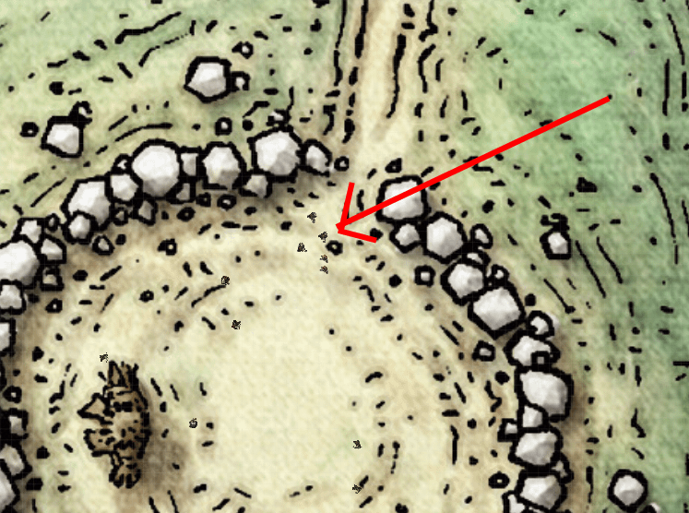](https://preview.redd.it/9rsl2ti24n741.png?width=747&format=png&auto=webp&v=enabled&s=dc59d3d89d042cd0edd285943b83a888b74a3ffc)[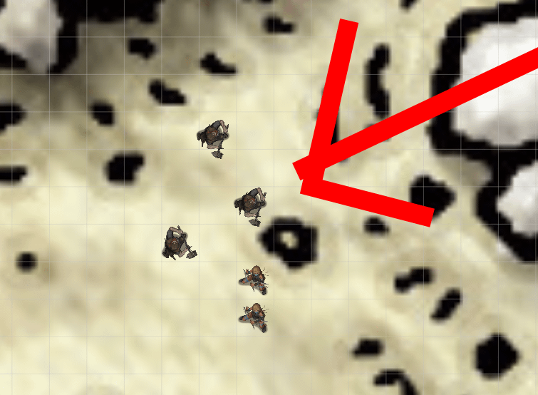](https://preview.redd.it/i7k5ysi24n741.png?width=755&format=png&auto=webp&v=enabled&s=d61f3012a80fad87b97e65a843ec636c8615434e)

### Wintersplinter

* + Here's the little conundrum I have with the event at Yester Hill.
    - On one hand, summoning Wintersplinter is *cool*. It's something right out of a high fantasy action movie and can really make the whole event feel like a dramatic climax. And if you *don't* have Wintersplinter awaken, the fight can end up feeling disappointing, even if the players win against the humanoid enemies.
    - On the other hand, summoning Wintersplinter almost completely ensures either a TPK or the destruction of a major ally: the Martikovs and the Winery. Or both.
  + I personally really wanted my players to see the giant Tree Blight go ape on them. I thought it would be a cool, heroic battle. *Boy was I wrong*. Wintersplinter absolutely *crushed* my party. This was definitely partly due to our misunderstanding of the map scale, but also due to the sheer number of enemies beforehand and the OP-ness of Wintersplinter itself.
    - As a reference, my players (party of 3) were about level 6 during this fight.

### Modifying the Battle

* + In order to ease this encounter for you guys, here are some changes I would recommend, especially if you're determined to see Wintersplinter in action. In my opinion, the Tree Blight battle should be the highlight of this encounter, so toning down the previous fights to accommodate it is a must.
    - Firstly, make the six druid enemies all simultaneously involved in the ritual, even though only one is needed. They should only join the main fight if absolutely necessary.
    - The berserkers are the main fighters. However, make them prioritize grappling the players and dragging them towards the exits of Yester Hill, away from the statue and the chanting druids. Let these guys serve as the ultimate bouncers, who are completely unafraid of pain or death.
    - Depending on the size and level of your party during this encounter, you may want to remove a berserker from battle, taking their numbers down to five or four. Or maybe have all six but take off one damage die from each of their attacks. I would personally roll some test attacks before this encounter and then rework things to make sure it's at least fair to your players.
  + ***Stopping the Ritual***
    - Let's face it, stopping the ritual is actually quite difficult as written. So long as at least one druid or berserker is chanting by turn 10, the ritual is completed. While it's possible they'll be interrupted, it's highly unlikely due to the number of enemies.
    - It's also unlikely that players will be able to destroy the statue before the ritual is completed, whether with fire or otherwise. Firstly, getting close enough to the statue to do harm would be tough. Even setting it on fire will take 5 turns to burn it down, rolling the best damage.
    - Basically, you should expect Wintersplinter to come to life. Which is why you should ease the berserker battle if at all possible.
  + ***On turn 10, Wintersplinter awakens.***
    - Once the Tree Blight comes to life, the druids and berserkers flee the battlefield for the tree line, taking opportunity attacks if they have to. Their primary objective is getting out of the way at this point and watching from afar.
    - I would modify the Tree Blight stat block a little to even things out for your players. Firstly, make it vulnerable to fire damage. Then reduce the damage done by Grasping Root to 1d6 bludgeoning at the start of a grappled target's turn. Lastly, make the Bite attack count as an action that can be used as part of its multiattack, not a bonus action.
    - While that *should* help, I would still run those test rolls prior to your session. While we certainly don't want battles to be easy, we should always want them to be fair. Adjust stats as needed for *your* game. If these changes feel like too much of a nerf, then only take one or two. Or, if you feel the whole encounter is actually *weak*, then by all means buff the enemies instead. The point is, adjust the encounter for your gameplay and players so that everyone has a fighting chance.

## After the Battle

### The Forest Folk

* + Once Wintersplinter is defeated, the remaining folk watching from the forest flee. Watching their effigy die is a very bad omen to the Strahd tribes, and they'll start to seriously doubt their vampire lord after this event. Even if the players don't realize it, they'll have earned some extra support from the native tribes of the valley.

### Your Players

* + It's highly likely that your players will be pretty beat up after this event. A PC or two might even be dead. I would like to reference my [mechanics post](https://www.reddit.com/r/CurseofStrahd/comments/aev7m9/fleshing_out_curse_of_strahd_prepping_the/), in which I recommend a ghost mode for dead PCs, giving them a chance to be resurrected before having to roll a new character.
  + You might also find Yester Hill a perfect place to implement the Beast Mode version of the PCs I talk about in my [Dark Powers post](https://www.reddit.com/r/CurseofStrahd/comments/9zswmf/fleshing_out_curse_of_strahd_running_the_dark/).

## The Mist Wall and Strahd

### Strahd

* + I'll be perfectly honest. I totally removed Strahd from this location. Though the forest folk in this event worship him, I just felt like adding in the big man himself was one too many plot points to worry about. Even if he just stands there and watches the battle, the players will end up dividing their attention too often in an already stressful fight. In the end, he would just feel like one more thing to keep track of in my opinion.
  + Of course, that's just my personal preference and you are more than welcome to keep him around if you wish.

### The Misty Wall

* + I also slightly changed the mist wall to better fit my alterations to the campaign. As I state in my very early posts on the Dark Powers and the separation of the Demiplanes of Dread, the mists are sort of like the space between dimensions. Since mortals can't actually perceive such a non-physical space, we instead interpret the borders as mist.
  + Anyone who stares into the misty wall at Yester Hill can vaguely see large, dark shadows (Dark Powers) moving in the distance and get a horrible sense of dread. This change from the beautiful, distant kingdom also further prevents players from willingly traveling into the mists.
  + Though it's doubtful a player will actually go into the mists, I've created some quick stats on what might happen if they do. Remember, the mist wall that surrounds Barovia is supposed to be dangerous. Barovians know that anyone who goes into them either find themselves back in Barovia or are never seen again. These stats/rules hopefully reflect that idea.
    - A mortal who goes into the mists immediately looses their sense of time and direction. There is no day and night cycle and the whole world is nothing but stone-like ground and a dense fog that limits vision to about 15 feet at a time.
    - A player who gets lost in the mists spends a minimum of 3 days there before they either come back to Barovia or die. Whichever happens will depend on their rolls in checks.
  + Have the player roll two checks for each day they spend in the mist.
    - First, have them roll a d20. Rolling a 1 means a Dark Power will find them and swallow them whole. Describe this event as a giant, shadow like horror descending on them. They should repeat this check each day they spend in the mists.
    - The second check on each day should be a DC 10 Constitution saving throw counting levels of exhaustion. Each failure will give the PC a level. The only change I would make is to Level 5, which should reduce their movement to 0. Instead, just say the players are crawling at a snail's pace.
    - If the players accumulate six failed Con saves, thus incurring six levels of exhaustion, they die. This happens even if they evade the notice of the Dark Powers swimming nearby. If the player accumulates three successes on their saves, they find their way out of the mists and stumble back onto the edge of Yester Hill, hungry, tired, and confused.
  + Should you have this happen, I would play it as a montage. Have the lost player roll all their days one after another and *don't* tell them their rolls count as days. Let them stay confused. Then jump to the other group and try to play with them a little. Tell them how they camp at Yester Hill after the battle or how they go back to the Winery, seeking help. Montage the days a bit before, *poof*, the mists spit out the lost player. Or, you know, the mists don't. DX

## The Spear

Alright, I made the terrible mistake of using this event to give a weapon to a player who hadn't gotten anything special yet. Curse of Strahd has a handful of neat magical weapons, but they're almost all made for fighting/heavy classes. There aren't any neat daggers or bows and the few existing magical staffs are evil. So, I felt a bit pressured to give something nice to the rogue in my group. Long story short, this spear was forgotten and lost within a couple sessions and no one really cared, myself included.

So, in short, don't use this event or this item unless you really have an appropriate player for it. If you really like the idea of hiding a weapon in the menhirs, create one more appropriate for your intended player. Maybe a bone dagger made by the ancients or a druidic staff of goodness. Either tailor the weapon to fit the intended player or don't use the event at all.

## Failing Yester Hill

Should your players fail at Yester Hill or outright ignore the quest, there may be dire consequences.

I personally try to save major events for the arrival of my players. I want the flow of the campaign to feel natural and work quite hard to get it that way. So, even if players go to Kresk first or something, Wintersplinter's rise would only occur on their arrival. However, player choices should definitely matter. So if players choose to ignore the plea of the Martikovs or approach Yester Hill and then decide to come back in a couple weeks without engaging, the rise of Wintersplinter shouldn't wait on them.

If players leave the event of Yester Hill for too long and definitely had the choice of tackling the quest, or if they attempt the quest but fail in one manner or another, you should consider putting in a follow up, butterfly effect event. In particular, a side quest where the Winery is destroyed and the Martikovs are either killed or captured is pretty cannon.

[u/DragnaCarta](https://www.reddit.com/u/DragnaCarta/) has a wonderful secondary event for this starting on page 20 of his [Winery guide](https://docs.google.com/document/d/1Bkhk9Y4ByngKwWw8bGzmWHx3WRxI0yr4m2_uS95wbE8/edit). If this becomes relevant to your game, I would highly recommend checking it out.

# Fleshing Out Curse of Strahd: Yesterhill II - The Gulthias Dungeon

Long story short: I created my own dungeon under the Gulthias Tree. I have hinted at this dungeon for so very long, it almost doesn't feel real anymore. I honestly don't know why it took me so long to write this all down, but the procrastination is OVER. Let's get going!

## Overview

I will totally admit that this dungeon was created to satiate some of my own storytelling desires. Looking through CoS, it's easy to spot quite a few excellent elements of horror. There are haunted houses, witches, evil castles, insane asylums, forgotten temples, and more. Honestly, the campaign is amazing for a horror buff like myself. However, I did notice that there was one horror not explored within CoS: the underworld. I wanted to incorporate a hellscape into CoS.

My dungeon beneath the Gulthias Tree is meant to reflect films like The Descent and As Above So Below, in which claustrophobia reigns and the dead walk with the living. I borrowed ideas and elements from both films, as well as others. At the same time, going through this dungeon is the path to reconsecrating the Mountain Fane of Barovia.

The wonderful and awe-inspiring [u/DragnaCarta](https://www.reddit.com/u/DragnaCarta/) has already created [a dungeon for the Mountain Fane](https://docs.google.com/document/d/1sJPhBg_f-osj9k092wQwZ6PBA401dUATyvHrvH8oIVA/edit), and it's totally dope if I do say so myself. However, prior to that write up, I'd already created this dungeon beneath the tree. Our dungeons are actually pretty different, so remember that if you don't like my take on it, Dragna's got his wicked version as well.

## The Gulthias Tree

### SPOILER ALERT FOR YAWNING PORTAL: SUNLESS CITADEL

* + Right off the bat, I want to say that yes, I read up on the Gulthias tree in the Yawning Portal chapter, "The Sunless Citadel". This tree is not like that. While interesting enough in that adventure, I decided to take this evil bit of shrubbery and completely home-brew it instead. So if you too are familiar with that adventure, go ahead and wipe your mental slate clean now.

### Death and the Fanes

* + In my [Fanes part 2](https://www.reddit.com/r/CurseofStrahd/comments/anird7/fleshing_out_curse_of_strahd_the_fanes_of_barovia/) post, I wrote about the symbology behind the Ladies Three. The Mountain Fane is essentially an ancient, nature based, death goddess. And while death can be extraordinarily terrifying, it is also a natural occurrence that should be respected and met with honor.
  + So I rewrote the Gulthias Tree around the Huntress, making it a living representation of her power. As written in both CoS and other iterations of the Gulthias Tree, such a tree is often synonymous with "evil." I really liked the idea of taking something so creepy and dark and making it good instead. While the tree is still technically a death tree, it's actually completely natural in my version.
  + As such, I didn't have the multitude of blights surrounding the tree and, thankfully, didn't need the stats for it either since my players didn't have to attack the tree.
  + However, if the tree is cut down, it can't be killed. Even by a hallow spell or something similar. The tree is directly connected to the Huntress, and so long as she lives, the tree will always grow back.

### Old Rituals

* + The forest folk of olden days used to bring their honored dead to the tree. A corpse left by the roots of the Gulthias Tree is slowly consumed by it, bones and all. In a month or so, the corpse would be completely gone.
    - I completely got rid of the corpse and the ax in the tree trunk as found in the book because of this btw.
    - Additionally, I've learned not to place magical weapons into a campaign unless they're tailored to my players. And none of my players would have been interested in a magical, plant hating ax. So yea, I just erased it.
  + The forest folk also used to bring heathens and heretics and hang them on the branches of the tree. At rope's length, it was harder for the Gulthias' vines to reach the bodies and consume them, meaning the corpses were often left to decay naturally. This was considered quite dishonorable and was a "burial" reserved for the worst of people and traitors of the Ladies Three.
  + Only the most notable of the forest folk were actually buried. Great leaders, the most honored priestesses, or people who had done some heroic deed, for instance. These kinds of people are buried in the stone graves around Yester Hill, close to the Gulthias Tree and therefore allowed to lay with Huntress evermore.

### Aesthetic

* + All the bark, roots and vines of the Gulthias Tree are black. There's no green to be found. It also doesn't grow leaves.
  + All parts of the Gulthias Tree have blood flowing within them. If the tree is cut in any way, it bleeds like an animal or a person.
  + A collection of old corpses and partial skeletons still hang from the tree. These are the forest folk's dishonorable dead.

### Rumors and Legends

* + Most of Barovia knows about Yesterhill, but only about a fifth have heard of the Gulthias Tree. Even less know it by name. Barovians that do know of the tree have a collection of varied rumors about it, its purpose, and its origin, almost all of which are untrue. Most commonly, it is said to be the site where the Morning Lord defeated a powerful demon. But again, this is completely false.

## What is the Gulthias Dungeon?

Alright, to make this dungeon work thematically, I sort of made up my own lore/logistics having to do with the planes of existence. I've done that sort of thing before in this series, but I always feel the need to put a disclaimer. The background and physics behind the Gulthias Dungeon is of my own making and in no way cannon (as far as I know) to dnd material.

Here's how it works:

### Planes and the Void

* + I'm sure there's some extra dnd lore out there on the dead and souls and all that. But I'm going to keep it as simple as possible for the sake of everybody.
  + I imagine the planes of existence like bubbles, floating around in a dimensional Void. Each plane/dimension is unique. Some are similar, some are very very different. Faerun, Ebberon, and the Core (the big dimension which Barovia is a part of) are all examples of planes.
  + The Great Void is only navigable by extreme magic or by certain beings. The Dark Powers, some celestial beings, and some gods are trans-dimensional beings and can therefore travel between worlds.

### The Realm of the Dead

* + The Realm of the Dead is a curious thing that isn't quite a plane or the void. Instead, it most resembles a giant, splitting river. It's a dimension in and of itself, but it doesn't exist in a pocket like the others do. This dimension stretches itself between worlds and lives within the Great Void.
    - So, technically, dead spirits from different worlds can meet here. If there's reincarnation in a world, it's possible the reincarnated soul came from a different plane entirely.
    - It's also possible for certain gods, who can traverse planes, to travel through the Void and into the Realm of the Dead to collect a soul and bring them back to life.
    - And lastly, this helps explain the Dark Powers and their search for souls to devour. When a person dies, their soul travels through the Void and to the Realm of the Dead. While in the Void, they're vulnerable. That's why in certain cultures throughout the planes, it is believed there are gods of death meant to protect souls on their journey to the afterlife.

### The Dungeon

* + In the caverns beneath the Gulthias Tree, travelers find themselves in a place where the dead and the living can meet as equals. It's sort of like an extension of the Realm of the Dead, poking through the Void and directly touching a plane, causing both to bleed together.
  + So, the caves under the tree don't actually exist in the material world. But they also don't exist in the Realm of the Dead. It's more like a perfect combination of both, like the center of a ven diagram.
  + But remember that the dead are not the only inhabitants of the realm of the dead. There are also a collection of fiends and celestials in the underworld and a few have taken residence beneath the Gulthias Tree.

### The Trial of the Huntress

* + Going into the Gulthias Dungeon means not only risking your life, but your soul (a popular theme in CoS already lol). The forest folk use the dungeon as a means of proving someone's worth. It was not so much a coming-of-age thing, but more of a path towards restitution and/or honor.
  + Only certain individuals were expected to traverse the caverns.
    - If a folk had done a great wrong, for instance, they could enter the dungeon. If they emerged alive, they were forgiven.
    - The leaders of the forest folk are all priestesses (female as a reflection of the fanes). Each tribe's high priestess had to have completed the trial to have earned her status.
    - If someone had a spiritual affliction (anything from an actual curse to a disease to a mental illness), they went into the Gulthias Dungeon to seek healing from the Huntress. Of course, they weren't always healed, depending on the nature of their affliction. Mental illness, for instance, isn't so easily treated, even by magic. But it was considered good luck to try.
  + In general, only one or two forest folks would enter the dungeon per generation. And, as possibly expected for a tree of death, the mortality rate is quite high. The majority of those who go in do not come back out.

## Entering the Dungeon

### Players with Purpose

* + The Gulthias Dungeon is meant to be a **LATE GAME** area, accessed by players who have already completed the Amber Temple. On their first visit to Yester Hill and subsequent battle with Wintersplinter, the players are not able to find the passage into the mountain fane, even if they thoroughly sniff around the tree.
  + Narratively, the dungeon can only be found by those who know what they're looking for. Only someone actively looking to enter the trial of the Huntress finds the entrance.
  + Mechanically, the entrance is hidden because the players don't have all the plot to fully understand the dungeon until they understand the fanes. Annnnddd also because players would probably die down there at lower levels. ;P

### The Entrance

* + The entrance to the dungeon is beneath the gnarled roots of the Gulthias tree. Players looking for passage can get on their hands and knees and find a vine covered tunnel, about three feet tall. You would have to crawl/kneel to get through.
  + After descending a short while, they'll come to the top of the dungeon map.

### GENERAL NOTE

* + It is highly advised that you count torches and/or other light sources for this dungeon. It's a long dungeon and it is very dark, and at later points darkvision will not help. After they enter the dungeon, tell your players to keep track. Give yourself an idea of how much time they spend down there too, so you can let them know when a torch is about to go out.

## Levels of the Dungeon

I split this dungeon into three thematic parts. The first is a more basic dungeon crawl. The second is heavily story based and reliant on your players. And the third is more pure horror with some fighting mixed in, ending at the shrine of the Huntress.

### Part 1: Creepy Caves

### Classic Dungeon

* + Like I just said, the first part of the Dungeon is a classic fighting crawl. While not incredibly interesting in concept, I felt like it helped lead players into a false sense of security by giving them a gaming concept they were familiar with. And then, as they continued their descent, things would get weirder and they would be more and more off-balance.
  + Because this part is a classic stab-stab delve, I pieced together a simple battle-map for you to use.
  + Find all full sized and unlabeled maps here: <https://imgur.com/a/WOiQcH2>

### Environment

* + After crawling out of the entry tunnel, players will find themselves in some winding, narrow passageways. This entire area is quite claustrophobic, the passages forcing the PCs to travel either single file or two by two.
    - This can make battle quite difficult. Remember that it counts as twice movement to move through another player's space. And it's an athletics contest to move through an enemy's space. (Unless anyone is small sized or less of course).
  + For the battle map's sake, this whole area looks level. But really the tunnels should go up and down in elevation. Though not necessary, it will do a lot of good for the atmosphere if you describe how a tunnel slopes upward or downward as the players move through the dungeon. Some changes might even be quite steep, if you'd like. The elevation changes are actually quite easy to read on the map and may also be interesting terrain elements to use during battle.
  + The walls are made from naturally parted, gray stone and hard-packed earth. Throughout the dungeon, the Gulthias Tree's roots cling to the walls like large, black vines.

### Battles

* + These are a collection of battles that can take place in Part 1. By **no means** do players have to fight everything on this list. But a few good fights that you, the DM, think would be fun are enough to get them going. This is simply a list of possible baddies that you may choose to throw their way.
  + *Rot Grubs*
    - Swarms of Rot Grubs are a personal nightmare to me. They're basically little maggot creatures that burrow into people's skin and eat them from the inside. I modified the stat block a little, but overall, that' the gist.
  + *Gricks*
    - While not the most complicated or the most dangerous creatures to encounter at this point in the campaign, four or five gricks can be a fun mini challenge in the tight tunnels.
  + *Alpha Gricks*
    - The gricks' parents that are a wee bit more dangerous. ;)
  + *Stirge Swarm*
    - You know stirges? Those giant fantasy mosquitoes? Well, I tried my hand at swarmify-ing them.
  + *Twig and/or Vine Blights*
    - Though thematically on point, don't make these enemies the star of the show down here. The party has already dealt with many blights and spending too long fighting another large group might seem redundant.
  + *Remorhaz*
    - This guy is by far the most dangerous creature on this list. If you think your players deserve a good a thrashing, consider putting in a Remorhaz encounter.

### Encounters

* + These are the most notable encounters I placed in the first part of the dungeon. Most include a chance for a fight, but don't have to have one. Also note that the locations I've marked on the map are only **SUGGESTIONS** for these encounters. Feel free to move them around or pick and choose which you'd like best. And even if you see multiple marks for the same encounter, know to only choose ONE, if you'd like.
  + ***A: The Corpse***
    - The players come across a rotting corpse. This might simply be a rotting Kreskite or a forest folk. It also might be someone significant to the campaign. Did the players banish Lady Watcher instead of killing her? Was there a dusk elf they promised to help but then forgot about? Does one of your PCs have a character in their backstory they're tracking down? Make this corpse *that* person, whoever the NPC is XD.
    - Unbeknownst to the players, the corpse is infested with rot grubs. There are four swarms nearby. One on the corpse and three in the adjacent squares. If players step up to the corpse or, more likely, try to loot it, and therefore step into the grub's space, the swarm gets a surprise attack and initiative starts.
  + ***B: The Beast's Lair***
    - This chamber is where the big boy lives. Depending on the size and/or level of your party, you might put one or two Alpha Gricks here, OR the Remorhaz. For heaven's sake, don't put too much or people will die.
    - This chamber is filled with soft earth, a noticeable difference from the rocky caverns. And throughout, there are several fissures in the dirt where the big worm bois have been tunneling.
  + ***C: The Sleeping Stirges***
    - This passageway has far more Gulthias roots lining its walls than the others and as players approach, they hear the low hum of insects. A swarm of thousands of stirges sits on the roots, drinking from the blood within. The bugs are actually quite docile here and it is possible to sneak past them so long as the party's stealth check stays above the swarm's passive perception. However, failing stealth will irritate and enrage the swarm, prompting battle.
  + ***D: LOOT***
    - Of course, there's loot. Why not? Here's some you might want to put in the dungeon at any of the marked locations of your choosing.
    - An old leather satchel, covered in grime. It contains a Barovian adventurer's supplies: 10 SP, 1 torch, 1 Potion of Climbing, 1 piton, and 50 ft. of hempen rope.
    - A single Tarokka card, laying face down. It looks new, but there are no signs as to how it got there. The card is the Death card and the player who takes it will have advantage on their next death saving throw, after which the card will disappear. (Don't tell them about this ability of course).
    - A small, deer totem carved from bone sits between the cracks of the walls. It is a magic item that contains 1 charge. When activated, the user is able to speak, read, and write Druidic for 10 minutes. The totem regains its charge at dawn each day.

### The Goal

* + The ending of part 1 is a single large chamber (labled E on the map), where players can have a safe rest if they wish. Though wide, the ceiling of the chamber is only about 5 1/2 feet tall, meaning taller players will have to crouch or kneel to move around.
  + ***Appearance***
    - One side of this cavern has the remains of an old campfire, which can be restarted if players have the abilities and/or supplies.
    - The stone walls are covered top to bottom in druidic writings and symbols from the forest folk (mostly from the priestesses seeking honor from the Huntress). The markings most often depict a crude, stick figure woman wearing an antler headdress. If someone can read Druidic they read short lines about the honor of death as well as a pictorial folk legend about how all of Barovia rose up around the Gulthias Tree, suggesting it is older than anything in their world.
    - Wedged into the ceiling are a variety of small charms hanging from strings of twine. They vary in variety from animal carvings to bits of feather and bone. You might see a tiny piece of coal hanging next to a human tooth, for instance.
    - The other side of the cavern has a low tunnel, about 2-3 feet high, that seems to slope gently downwards. The tunnel is rubbed smooth from years of travelers crawling through. The stone around the mouth of the tunnel is noticeably devoid of markings and offering, except for a single druidic line etched above it. If translated, it reads, "And they shall be made to crawl on their bellies into the realm of the gone."
  + This chamber is a resting point in the dungeon. It is safe from attack as some ancient magic keeps the creepy crawlies away. This is also the last point where players can actually turn back. Beyond this point, leaving the Gulthias dungeon means either completing it or death.

### Downward

* + The only way forward at this point is the tunnel. So that's where the players will go next.
    - I've already stated that this is a NARROW tunnel. The players will have to crawl on their bellies to get through.
    - Now, you should know your PCs by now. You know which of them are big boistm and which of them are not. The larger PCs are going to have to roll dex saves to get through the tunnel, and the DC is going to be either better or worse based on their choices.
    - Let's say the Goliath Palladin is going through. Ideally, they strip off their armor and put it in a bag to either push in front of them or drag behind them. Maybe they even look for a way to make themselves slicker, asking the rogue for their last flask of oil (eyebrow wiggle). Maybe you've got that shameless character that tells you they skip dinner that night and make sure to take a big poop to lighten themselves. Whatever. The point is, they make an honest, intelligent effort to fit through the tunnel. Dex Saving Throw DC 10. Maybe even 8, if you're feeling generous.
    - Now let's say that same Goliath instead dives head first into the tunnel, full armor and backpack on. That armor is metal and not pliant at all to twisting, shifting, passages. DC 19. Let that dummy get stuck.
  + ***Getting Stuck***
    - What's the result of all this? Role-play. Though a rather ridiculous circumstance, a group of PCs trying to figure out how to un-stick a stuck PC, Winnie-the-Pooh style, is *hilarious*. The better they do, keep on reducing that DC appropriately.
    - Maybe they tie a rope to the stuck PC's feet and all pull. Maybe the single PC behind them pushes. Is that an Athletics check on their part instead? Maybe the mage casts *grease* around the player and just maybe that same mage had to take a long rest to even prepare the spell, meaning Mr. Stuck has to sleep in the tunnel XD.
    - Now let's say the stuck player and the other PCs fail any and all checks to unstick the player. It's quite possible the player will starve to death in there. Possible but just improbable enough to make this funny.
  + ***The End of the Tunnel***
    - So the players all single-file it down the tunnel on their stomachs, following the slope slowly downward. They descend about 200 ft and it takes them a *while*. The player in the lead reaches the end first.
    - That player finds themselves staring downward into a black abyss. If they have darkvision or a light source, they see that they're actually in the ceiling of the next chamber, staring at an enormous pool of still, black water far beneath them. One side of the chamber has a rocky shore and a single, visible exit.
    - The players all fall, one by one, out of the tunnel and into the water. Though this seems ominous, it's actually nothing to worry about. There are no monsters in this chamber lurking in the deep (unless you really want there to be lol). The water is simply there to break their fall.
    - The point of this room is that it's nearly impossible to go back the way they came, unless they have a flying ability. And even then, it's very unlikely they'll be able to all go and therefore will be forced to split the party if they want to reverse.

### Part 2: The Meeting Place

* Location Rules
  + Once the players leave the underground lake, they find themselves in a series of much larger caverns that are pitch black. The darkness is a pervasive, magical darkness which limited all sight to 2 ft radius. All PCs, regardless of darkvision, are now blind, only able to see about an arm’s length in front of them at a time. Torches and other light sources still work, however and seem to literally push the darkness away to their radius.
  + This section of the of the dungeon is where the Realm of the Dead and the Material Plane officially meet, blending into a locational singularity where the players are both alive and dead at the same time.
    - While in these caverns, players can't die. They can still go down, and if they do fall to 0 HP while in turn order, still have them roll death saves. But even if they reach that dreaded negative three check marks, don't say they're dead. Just keep making them roll death saves. The confusion and tension will be *real*. Either another player can come stabilize them or revive them, or they'll go back up to 1 HP after an hour.
  + There is no map for this section of the dungeon because the chambers themselves shift and move. This isn't the Material Plane, so the environment itself is very unstable and impermanent. The caverns of part 2 are ever-changing. However, you will likely need a battle map or two. A simple, reusable cave map should suffice.
  + Lastly, because this area is a singularity with its own rules, certain abilities become null. Players can't, for instance, summon familiars from the other planes. Players with deities or dark powers can no longer commune with their gods. This particular mini realm is owned exclusively by the Huntress and no other god or god-like being can enter here. Magic that summons life from another source, say conjuring elementals or fiends, would similarly be impossible.
    - However, players *can* summon dead or undead is they possess such abilities. Like I said, this realm is a literal mixture of the Material Plane and the Realm of the Dead. So the dead can pass through.

### Separation

* After players leave the lake chamber, your first move as DM is to separate them. This isn't difficult, as most of it is magical in nature and done through description anyway. It's still fun to see them panic. The best way I have to describe this method is to give you an example:
  + Group of 4 enter the first dark chamber, holding up a torch.
  + Bob turns and sees a light in the distance, from a candle maybe. He decides to scout towards it for the party and leaves the torch's light. Bob reaches the candle, but finds nothing else. He turns to call to the party, but looks back and realizes he can't see their torch light. And they aren't answering.
  + Meanwhile, the party watches Bob go into the darkness to scout. They wait for a few moments and then suddenly the candle light disappears. They panic a bit and call out for Bob, but he doesn't answer. As a group they race to where the candle light was, but find nothing. The party regroups, they form a line/marching order to search for Bob. Jim is first in line, carrying the torch. Sally is last in line. As they walk forward, Sally hears someone call her name from behind her. She whips around to look. Maybe she even says, "Did you hear that?" But as she stares into the darkness, the torch light suddenly goes out. She lights one of her own frantically but finds that she's alone. And the rocky walls around her look completely different than they did only a moment ago.
  + Jim and Danny continue walking. They didn't hear Sally stop and didn't hear her words at all. Danny asks Sally a question and when she doesn't answer, they both turn and see she's gone. They start to panic and argue and plan. Suddenly, there's a gust of cold wind that tries to knock them down. Dex saves. Pass they stand, fail they fall prone. All the same, the torch goes out.
  + Jim gets the torch going again and in the light, Jim and Danny see that they're standing on opposite ledges of a wide chasm that wasn't there before. They're at least 100 ft apart and have to speak loudly to be heard. They're each forced to take different tunnels to try and regroup and are thus separated.
* ***Playing with a Split Party***
  + Even though you've split up your players, don't leave anyone alone for too long! I've seen this happen before; DMs disappearing for hours with one or two PCs while the others twiddle their thumbs. That is *not okay*. You spend maybe ten minutes or so with one player and then switch. Keep on cycling through players so no one feels forgotten or left out.
  + This ideal includes turn order. If a single PC gets into a fight, maybe only do a couple turns of battle and then switch. Don't sit on the battle until it's finished.
  + Also know that this section doesn't really require private DM chatting. You don't have to DM for one player at a time while the others wear earmuffs, lol. It's okay for everyone to hear what's happening, so long as they don't intervene when their characters aren't there of course.

### The Dead Cometh

* + One other unique property of this section of the dungeon is that the dead can sort of sense living people who are visiting. And many of those dead people would like to say, "Hi," for better or worse. ;)
  + While the players are separated, dead NPCs will come and meet them. Some will have conversations. Some will be angry and want to fight. This part of the dungeon is very personalized towards your players and will vary from campaign to campaign. As such, I can't give you any absolutes on who should appear. But here are some ideas to consider:
    - Does your PC have any dead parents or relatives you think they would benefit from seeing? Maybe someone has daddy issues and wants to know why their father left home and never came back. Or maybe the PC never had the chance to meet their mother who died in childbirth.
    - In this case, a lot falls on you, the DM, to create a personality for the backstory NPC. Is the mother proud of her son and wants to tell him that? Maybe she was a jovial woman, looks her son up and down and says, "Oh thank Lathander you look like me! Your father was as ugly as his heart was sweet." Or maybe this is your opportunity to reveal someone's parent was a Vistani.
    - Throughout the campaign, did your players happen to cause someone's death who still had something to say? For instance, what if Urwin Marticov died during the Vallaki catastrophe and never got to give the players a critical piece of info? Does his spirit take the opportunity to have that chat with a PC and forgive them?
    - Or, on the opposite end, maybe the players caused an unjust death. Maybe some chaotic PC stabbed an innocent Vallaki guard and now that poor guard is angry af. He had a wife and four kids and he was going to retire in two weeks. Give that guard a buffed stat block and go ham on that PC. Make the guilt *live*.
  + Just like the PCs in this weird, quasi plane, the dead can't actually die. They're not technically alive to begin with, so they can't be even more dead. If they fight the PCs and the PCs win, they fall to the ground and the darkness swallows their forms. Because they're not technically dead, you might even choose to have another encounter with them, if you feel it necessary.
  + Also, the dead appear whole here, as they did the day they died. They're not spectral or see-through or rotting. They appear whole and otherwise unharmed, wearing the same clothes they died in. This further blurs the line between life and death in these caverns.
  + ***Number of Meetings***
    - Overall, don't overload the players with meetings. You don't want this section to last forever, after all. Pick and choose two-ish dead people per PC. Also, don't spend too much time in a conversation. If you have that overzealous player who wants to have an hour long conversation with their dead sister, try to limit them. Imply that the dead can't stay forever. Have them say what needs to be said and then end the encounter. The player blinks and the dead person is simply gone.
  + ***A Universal Message***
    - Part 3 of the Gulthias dungeon will rely heavily on climbing and darkness. If you happen to have that party that doesn't have *any* rope or are running very very low on torches, lamp oil, or other sources of light, this is the last opportunity you have to help your party. You may, at your own DM discretion, have a friendly dead person gift them some supplies for the journey to come.
    - Though not *necessary,* there is a message/clue I would recommend you give your players at any point during their meetings with the dead. While a PC is chatting, the "How do we survive this dungeon?" question is bound to pop up. Or, you know, something similar. Basically at least one player is going to ask for info or advice on how to proceed. Now is your chance to be super cryptic and rule that the ghosts can't really admit to much. Instead they give the same exact line to anyone who asks: "The only way out is down." This line can really set a *mood*.

### Reunion and Onward

* Once players finish with their last meeting, they find themselves in another empty chamber. One by one, as you continue to cycle through your split party, each PC finds themselves in the same room. "You round the corner and see a figure holding a torch. For a second you think it's another ghost. But then you realize it's Bob!"
* The players have the opportunity to RP here and talk to each other if they want. But now they must continue onward. Or, er, downward. XD
* ***One Way Forward***
  + In this last chamber, along the far wall, is a rather sizable crevasse in the floor. The gap stretches the length of the wall and is about five feet wide. This crevasse is a straight, vertical drop down into darkness and it is the way to progress.
    - While yes, much of this section is quite railroad-y I think that the depth of RP available in this section of the dungeon is well worth it to players. Just remember to let the players make their own decisions on which way to go and try to weave those choices into which way they've got to go anyway.
    - Most certainly, at this point in the dungeon, going back is impossible. With the shifting nature of the caverns in part 2, getting back to the underground lake room isn't going to happen. If players try to leave and don't go down the crevasse, just shift rooms around until the crevasse just reappears, giving them little option. Yes, like I said, railroad-y. But hey, sometimes you gotta.
  + The drop down from the crevasse is 120 ft deep (this may be reduced to 90 ft if you have a particularly weak party), so jumping down isn't an option. Players have to climb. If they drop a torch down, they can gauge the distance with a check most likely. This is where having a rope is a life saver. Or, if you have that player that's been hording a climber's kit all this time, now is their time to shine.
    - To free climb the wall is a DC 15 athletics check for every 30 feet. A PC will have to make the check 4 times to make it the whole way down without incident. If they fail the check, they fall. And if there's nothing there to slow or break their fall, they'll have to roll fall damage for however many feet are left of their climb down.
    - If the players have a rope, they roll their checks with advantage. But remember that most rope is only 50 ft long. They might have to combine two pieces or come up with a secondary plan to keep that advantage.
    - At your discretion, there might also be some old rope leftover from the last forest folk who traveled through this passage. However, this rope is old and withered. Each time a PC makes athletics climbing check, make a secret; DC 10 check to see if the rope snaps or not.
  + This obstacle is very similar in nature to the narrow tunnel leading from Part 1 to Part 2. I really like environmental challenges that force players to think critically to solve problems, instead of just throwing their stat blocks and proficiencies to auto-fix dilemmas. Do the players give themselves some other safeguards against falling? Maybe they tie the rope around themselves or set up piton points or get the two strongest PCs to the bottom with an old-school fireman cloth catch ready. Whatever they do, I find it interesting. ;)

# Yester Hill III - The Trial of the Huntress

Hello and welcome! In this post, I'll cover the second half of the Gulthias Dungeon, a path into the underworld to reconsecrate the shrine of the Mountain Fane.

## A Quick Recap

* The Gulthias Dungeon is a late game area meant to be tackled after the Amber Temple and before Castle Ravenloft. By completing the dungeon, players will have reconsecrated the Mountain Fane, a key step in weakening and then defeating Strahd. For more information on reconsecration and the Fanes in general, check out my [Fanes posts](https://www.reddit.com/r/CurseofStrahd/comments/9l5zfh/fleshing_out_curse_of_strahd_the_fanes_and_the/?utm_source=share&utm_medium=web2x).

### Part 1

* + In part 1 of the dungeon, players crawled under the Gulthias Tree's roots and entered the caverns beneath. They fought some creepy crawlies and otherwise had a pretty basic dungeon crawl.
  + They ended Part 1 in a cave covered in druidic runes and found a narrow tunnel leading downwards.

### Part 2

* + After crawling through the narrow tunnel, players will have unknowingly crossed from the Material Plane and into a mixed, planar space that crosses the real world and the Realm of the Dead.
  + This section of the dungeon has a pervasive, magical darkness that forces players to use torches or other light sources. It also has shifting, strange corridors that inevitably end up separating the party.
  + While the party is separated, each PC has a couple meetings with dead people they once knew. These people might be long lost parents, angry folk that they murdered, or lost NPCs you think would have an impact on them. They meet, they chat, they maybe fight, etc. No matter what, it's a big RP section that is very individualized for your players.
    - Throughout these encounters, all players receive the repeated line that, "The only way out is down."
  + At the end of this section, the darkness reunites the players in a cavern with a large crevasse leading straight down. Players climb down and end up in Part 3.

## Part 3: The Great Darkness

Once players successfully climb down the crevasse, they stand together on a great, earthen platform. This section of the dungeon further distorts the line between the Material Plane and the Realm of the Dead, and is home to far more wicked creatures of the underworld than simple, dead spirits.

### Environment

* + This section of the dungeon is literally an enormous cavern that stretches off in every direction. The ceilings are so high, they might as well not be there at all. And while there are walls, they are very, very far apart.
  + The vast majority of this cavern is filled will bones. Thousands upon thousands of bones. They literally clog the floor, and are layered so thickly you can't see the stone floor beneath them. Most are humanoid in structure, though there are also animal bones of various species mixed in.
    - The bones make sneaking very difficult. All stealth checks are made at disadvantage as the bones clack beneath the players' feet. This is also considered difficult terrain, limiting the players' movement.
  + Like the previous section, this whole area is filled with an overwhelming, magical darkness that limits player's vision to only about an arm's length. Players will have to use light sources to literally push the dark away.

### The Living Dark

* + In this part of the dungeon, the darkness is literally an enemy. Except, it doesn't have HP and it isn't killable. While there are actual enemies in the cave, they are not the same as the darkness. The Dark's goal is to kill the players. That's it. It's not intelligent and has no mentality, instead it's simply more like a malevolent, deadly force; not much different than fighting a room full of magical poison gas.
  + Mechanically speaking, the Dark is pretty much an area effect. Here's the stats you'll need:
    - Initiative is a straight d20 for the Dark.
    - Any target in the Dark is completely blind, unless they are creatures/monsters native to this area of the dungeon. They also cannot see light in the distance, even if they are standing literally 5 ft outside of a torch's light, they can't see that light. Blind means blind.
    - Any target in the Dark must roll a DC14 Constitution saving throw at the start of their turn, or take 2d6 necrotic damage or half as much on a successful save.
    - As an action, the Dark can try to grapple (+5 to attack) a target within light, within a 10ft reach. When this happens, it looks like the darkness is literally bubbling forth and reaching towards a target. On a successful grapple, the target is yeeted out of the light and pulled 10 feet into the darkness.
    - If a light source only has a radius of 10 ft (from a candle, for instance), the Dark will go for the light source instead of a grapple. The Dark makes an attack roll (+5 to hit) against the light wielder's AC. On a success, the light goes out. If the light isn't being held, like a candle placed on the ground, the Dark automatically hits and the light goes out.
  + It shouldn't take too long for your players to figure out that this darkness is bad. They'll have to cluster around light sources to stay alive, keeping their distance from the edge of their light's radius.

## Map

### Giant

* I made this map humongous. From a distance, it looks pretty bland. But I really like the idea of having players just being in this overwhelming space with no sense of direction.
* If you're playing remotely using something like Roll20, like I do, you might have access to dynamic lighting. And that makes big maps like this really flipping *cool*.
* If you're playing in person with a physical map, resorting to theater of the mind can be pretty cool too. Picture this: The players are moving up to their speed each turn. "What do I see, DM?" "Bones and darkness." Next turn. "How bout now?" "Same." And so on.
* There's this idea that the players are lost without landmarks all while in an obviously hostile environment. And when they *do* get into a fight, there's plenty of room for both the players and the enemies to move around.
* Find the full sized, player map [here](https://imgur.com/a/WOiQcH2)!

[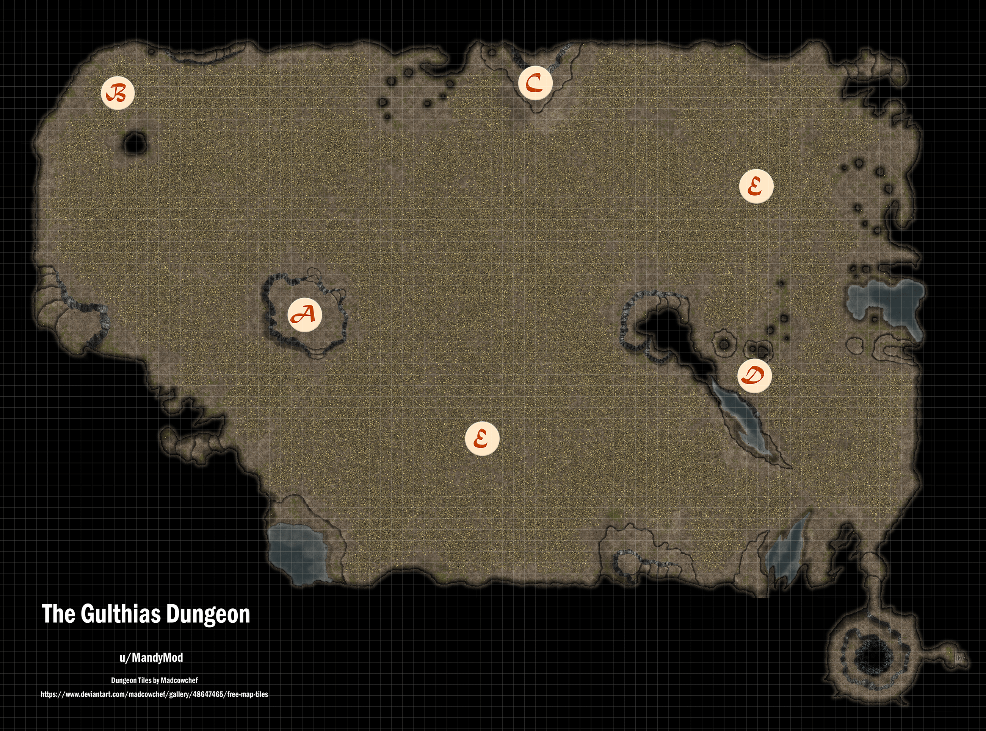](https://preview.redd.it/tom81fmcsq151.png?width=2601&format=png&auto=webp&v=enabled&s=a39345a9e4409d947c7e03b111ec18d9c1be19cb)

## Encounters

### The Goal

* The goal for part 3 is actually pretty straight forward. The players are trying to get to the little tunnel on the lower right-hand side of the map. That little room contains the Shrine of the Huntress and is the ending of the dungeon.
* Until then, players wander around in the dark, either fighting or avoiding monsters beyond their wildest nightmares. This is survival of the fittest.
* However, you can give your players one crucial hint as to where to go. The whole cavern seems to gently slope towards that southeastern tunnel. Even with all the bones, the slope is there and noticeable to any player that looks for it. If they remember that "The only way out is down." line, they'll know which way to go.
  + If by chance you have players with horrible memory, horrible note-taking, or both, you can help them out with checks. If a player wants to look for some clue to figure out where to go, have them roll a DC 12 perception check to notice the slope. If a player is having trouble figuring it out anyway, you can also have them roll a DC14 history or straight intelligence check to remember the clue.

### Gameplay

* Upon entering this new area, go ahead and roll initiative. You'll need it. The Dark is the only enemy you need to worry about rolling for right now though, so there's room for talking and role-play. Once the party gets going, the initiative becomes more important.
  + Side Note: I totally used this section to go ham on Tomb of Foes enemies. Because we so rarely get to use high level, cool enemies. I thought it was time to throw players for a loop. Hehehehehehe
  + ALSO. This list has more than one high level encounter. Remember that just like with encounters in the written CoS book, you DO NOT have to use all of these options. Pick and choose which fights sound cool to you. But also remember that your party should be about level 10 now and should be able to handle a great deal.
* ***A - Start***
  + Players begin on the platform marked A. Give them time to catch their bearings and figure out the Dark is actually dangerous now. But inevitably, they're going to have to get down into the bones.
* ***B - Howlers***
  + A pair of Howlers (pg210 ToF) prowl in this area. Remember that their passive perception is 15, so that's the stat to beat for a group stealth check across the bones. You know, if the players try to stealth in the first place.
  + The first time the Howlers hear noise from the party, one lets out a piercing howl that echos through the cavern (not an attack, just the sound effect for spookiness), and they both begin to race across the bones towards the party. Add them to the initiative.
  + These guys are nasty. Their howls can force players into the darkness after being frightened, which can be deadly. If the battle ends up super easy (which can happen if players are particularly lucky with their rolls) consider adding a third Howler that brings up the rear. Remember to try and divide and conquer, and don't forget those pack tactics.
* ***C - Oblex***
  + Hearing the death rattles of the Howlers will spark a new, far more intelligent enemy into motion. In the northern part of the cave is an Elder Oblex (pg219 ToF). These oozes absorb the memories of their victims and can create doppelgangers of them to lure in new prey.
  + If you fear an Elder Oblex might be too strong for your party, you can demote this beasty to an Adult Oblex.
  + Anyway, once the Howlers die, there's a quiet moment where the party collects itself. And then they hear a woman's voice call for them from the darkness. It's heavily accented, but clearly afraid. This woman is one of the Oblex's simulacrum, taking the guise of a fallen forest folk priestess. She leads a small band of other simulacrum (however many you've rolled) and lies to get the players closer.
  + She holds a torch and says that her group has stayed silent to hide from the howlers, which is a lie. She does have all the information that a priestess of the forest folk would have and if she talks about any of that, it's the truth. However, she does make a claim that the shrine of the huntress doesn't exist and that this place is nothing more than an early casket, which is also a lie. If asked how the group has survived so long, try to make something up. Maybe imply they've been eating corpses, lol.
  + Besides the simulacrums' lies, there are only two other tells to give them away. One, they smell faintly of sulfur. And two, there are thin trails of ooze at their ankles, leading back to the ooz's main body, far back in the darkness. This connection is immune to damage, but not space. A wall spell, for instance, can sever the connection by forcing a disconnect. The ooz trail requires a perception check of 16 to notice (a passive perception of 16 or higher sees it automatically).
  + Once the simulacrums feel like they've decently maneuvered themselves to surround the party, one steps up close and attempts to memory drain a player and battle begins. Remember that even though there are a lot of simulacrums, there is only one enemy on the turn order, so all of them can't attack on their turn. Any damage taken by the simulacrums is taken by the main Oblex, so it appears like they never truly take damage. And when it finally dies, the Oblex and its simulacrums turn into lifeless, red sludge, which is a neat visual.
* ***D - Corpse Flowers***
  + You can't have a tree of death without thinking about Corpse Flowers (pg127 ToF). There are 3 of them in the southeastern side of the map, clinging to the walls, pillars, and stalagmites. If a PC goes within 30ft of one without sneaking, that Flower wakes up and starts to fight them.
* ***E - Rutterkin***
  + Lastly, there's a couple small packs of Rutterkin (pg136 ToF) that wander in the remaining open areas. They're in constant search of prey, but very rarely find it. So if the party attracts their notice, they'll come quickly.

### Overall

* As with all my notes on other CoS locations, you most certainly don't have to use *all* of these encounters. If your party is struggling, don't be mean and massacre them. You should always try to make fights fair. Pick the encounters that sound cool to you.
* Really, it's probably much safer to try and stealth your way through Part 3 than to fight everything. Between the enemies and the horrible darkness, this is a very dangerous area. But one way or another, the party will end up in that tiny chamber at the end. That chamber is the Shrine of the Huntress.

## The Shrine of the Huntress

The players have now reached the final section of the Gulthias Dungeon.

### Features of the Chamber

* + While small overall, especially compared to the last section of the cave, this chamber is the most important of entire dungeon. The whole area has a sort of funnel effect, with a large hole, about 10 ft in diameter, in the center. This pit has a quite literal endless depth. If players drop a light down the hole, the light falls and falls and falls before winking out of view. There's never any sign or noise to tell if it hits bottom.
  + The roots of the Gulthias Tree all culminate here, covering the walls so thickly that the stone beneath is all but invisible. The roots stretch down the walls, spread across the floor, and dip into the central pit, disappearing into the darkness.
  + The only other feature of the chamber is a small alcove on the side of the room, containing the Huntress' shrine. The shrine is a large, carved statue of an inhuman, but beautiful woman with giant stag horns growing from her temples. The stone of the statue has veins of various gemstone streaking through it, giving it this sort of rich, ethereal effect.

[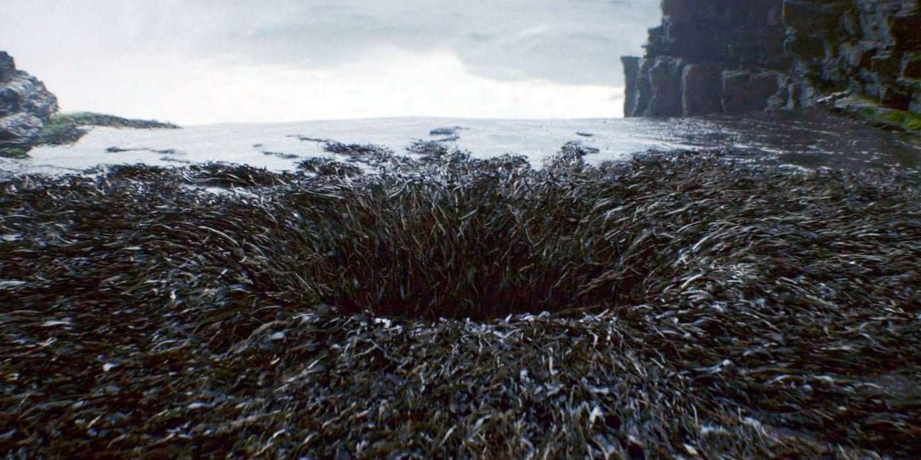](https://preview.redd.it/6u58gfxesq151.jpg?width=1400&format=pjpg&auto=webp&v=enabled&s=8a7954f37845d861eba0732386a4450c72c352ca)

*Yes, this is from Star Wars. But this is sort of how I imagine the pit looks, with the thousand Gulthias roots going into it.*

### Interacting with the Statue

* + The point of this chamber is to have at least one of your players touch the statue. Doing so will induce a series of visions from the Huntress. Some visions will be personal, others more general. I've gone ahead and written out a list of examples and visions that you can pick and choose for whichever player you like.
    - You see your mother, sitting before a mirror and brushing her hair. But her hair is not hair, it is long, black vines and there are flowers where her eyes should be.
    - You see a circle of women, their hair tangles and woven with flowers. They smile, hold hands, and dance together in a circle under the moon light.
    - You are a hunter in the forest, bow in hand. As you move through the brush, you see a large stag. You take aim, hold a breath, but then the stag hears you. It turns its head and you see it has the grinning face of a woman.
    - You are in this chamber, but the party isn't there. A small group of armored men stride in, raise their blades and begin cutting the roots of the Gulthias Tree. As they hack away, you watch as the roots themselves seem to morph, changing into the small figures of naked women, screaming as they are torn apart.
    - Three woman stride through the woods. Together they sing a hymn you've never heard. But the moment you hear it, you know it is not human. The song is of life and death, past and future, love and hate.
    - You see a man dragged out before a tiny village, streaked with blood. His wife crouches behind him, holding the body of a murdered child and weeping. The man has a rope bound around his neck and he is hanged from a branch of the Gulthias Tree, where you see him rot.
    - You see a long stretch of land, barren and waste. Before you, a tiny black stem grows from the stone. Time speeds by and the stem grows into a black sapling, before growing into a tree. The land changes and grows around it, mountains rising, forests growing.
    - Strahd stands before you, his hands wrapped around your neck. You struggle, but you're suffocating, dying. Suddenly you are behind Strahd, and his hands are around the neck of a woman with horns.
  + No matter what sequence of visions you wish to use, they all end the same way: with the pit. Somehow, someway, the PC sees themselves falling into the pit.
    - You are in a realm of darkness. You feel your heart race and your breath quicken. You turn around and suddenly come face to face with a living version of the statue; a woman with angular features, stone skin, and deer antlers. In one swift motion, she pushes you and you fall in a familiar pit.
  + After this final vision, they come back to themselves standing before the statue. Every PC that touches the statue will have the same final vision. And with little else to do, they should figure out they need to jump into the hole at the center of the room.

### Down the Hole

* + One by one, players should jump into the pit. Once the first PC gets the courage to take the plunge and doesn't immediately die, the others should follow without much struggle.
  + The fall is long and dark, long enough to let them know that they're falling far enough to kill them. But then, when they hit bottom, they land with a solid thump on a spread of soft earth. The fall should knock the breath out of them, but doesn't hurt them at all.

### And Out the Other Side

* + The bottom of the pit is nothing but earth. The walls are solid rock and there are no passages or tunnels. But the ground is soft and somewhat spongy, giving a bit under the PCs' weight. After some questioning and possible skill checks, someone will get the bright idea to dig into the ground. That's good. That's the way out.
  + The moment they get more than a few inches into the dirt, they poke a hole through and a beam of light comes shining up from the floor. They've been underground for so long; this pure light blinds the players for a moment. When their eyes adjust, they can widen the hole and look through it. And they'll see clouds and sky far beneath their feet.
  + The players are now in fact upside-down, sitting on a thin layer of earth. When they climb down through the hole, they can feel the shift in gravity as they turn and roll out onto solid ground, directly in the middle of the standing stones of Yester Hill. One by one, they pile out. And when the last person goes through the hole, the earth sinks a bit and the exit to the underground is gone.

[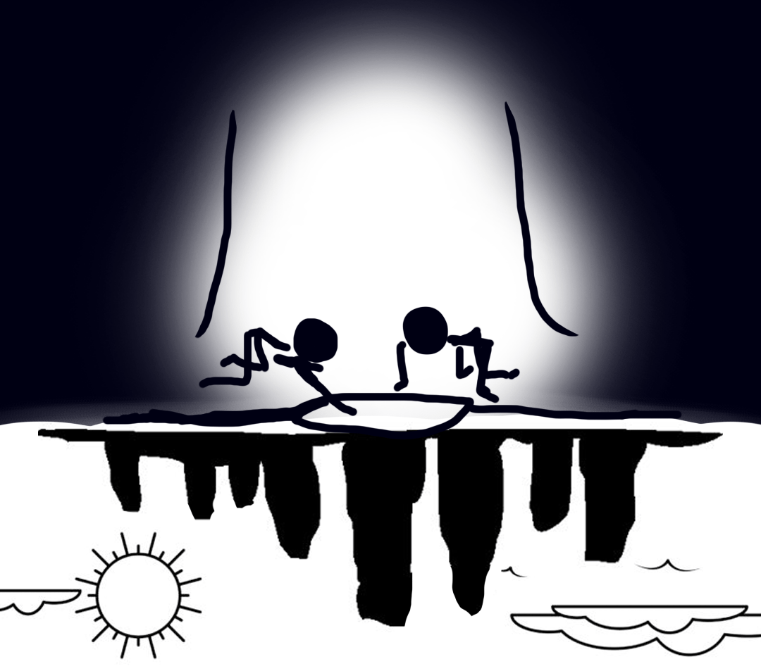](https://preview.redd.it/uf7576plsq151.png?width=1080&format=png&auto=webp&v=enabled&s=e52be2b83e511bc361f055a16445e98a3cd1e288)

*My very primitive, mouse-drawn sketch of the ending of the dungeon. Hopefully this helps you understand my point. XD*

## The Ending

Now, the party has exited the Gulthias Dungeon and sits together in the center of Yester Hill. By surviving this passage, they have officially reconsecrated the Mountain Fane and have earned the favor of the Huntress. They likely deserve a level up after all that. XD

Otherwise, the group can sort of feel a shift in the atmosphere, like a change in the winds. Though everything looks the same, something is invariably different from their trial. In addition to this trial, players will have to reconsecrate the other two fane shrines, as detailed in my Fanes posts. But if this happens to be the final shrine they tackle, they might emerge to the Ladies Three and their gifts.

------

That's the ending of the Gulthias Dungeon, guys! Thanks so much for reading and I hope it's an interesting dungeon for you guys, with a fine mix between a dungeon crawl and role-play. Also, I apologize for this last long absence. Unfortunately, real life got really weird and hectic and I had to place reddit to the side. But we should be moving on to Castle Ravenloft now! Yay! Until next time.

-Mandy